Contents
DATA LEAKAGE 1
CONFIDENTIALITY EXPOSURE 3
SHADOW AI 5
TOKENMAXXING 6
VALUE LEAKAGE 7

DATA LEAKAGE
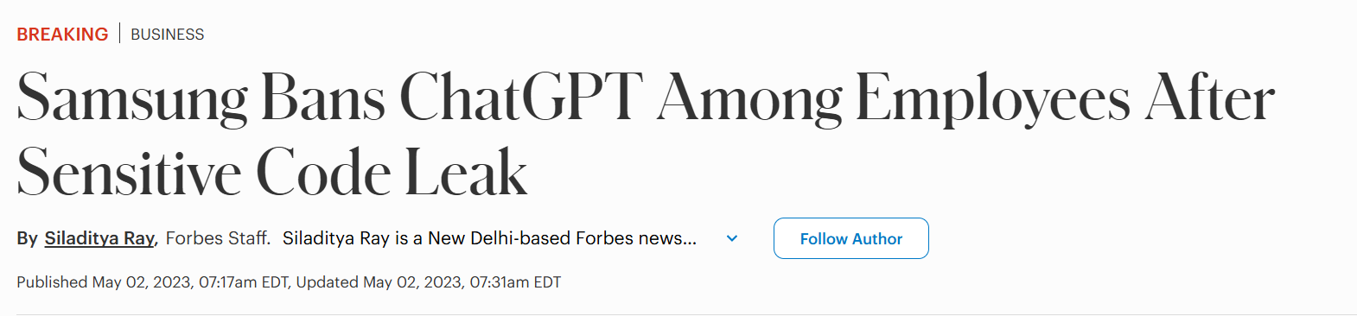

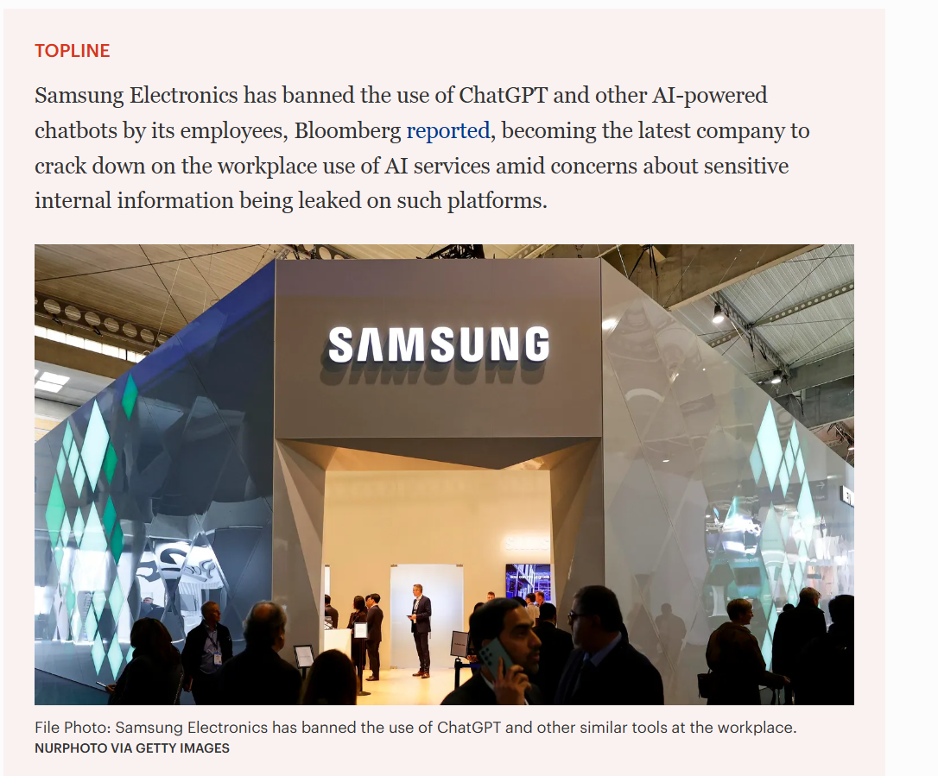

Headline
Samsung Bans ChatGPT After Sensitive Code Leak
Source
FORBES
Date
2 May 2023
Risk Tag
DATA LEAKAGE
Description
Following multiple incidents involving confidential source code and internal information being uploaded to ChatGPT, Samsung imposed company-wide restrictions on generative AI tools. The case highlighted the risk of sensitive information leaving organizational boundaries.

CONFIDENTIALITY EXPOSURE
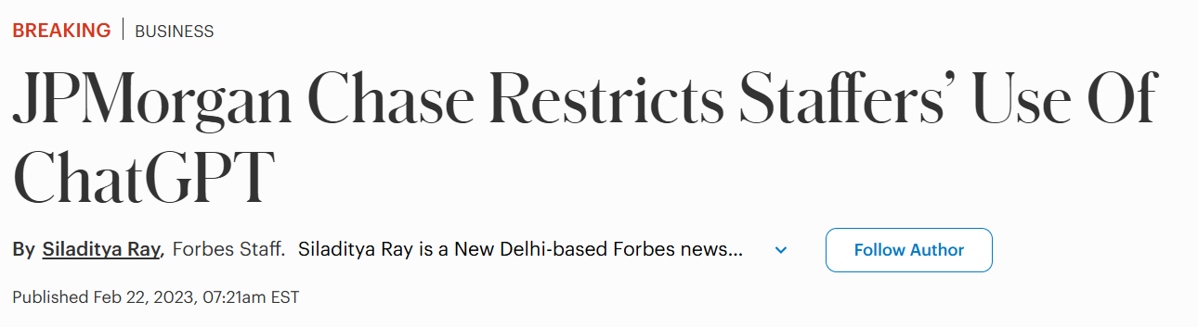

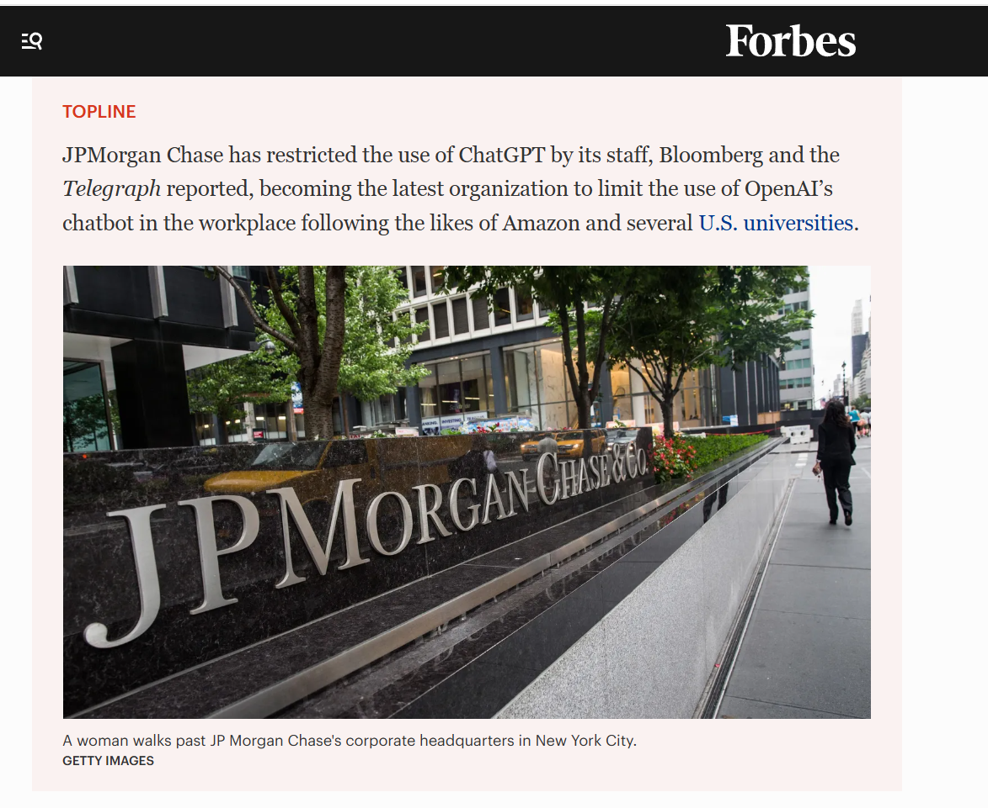

Headline
Major Banks Restricted Employee Use of ChatGPT
Source
FORBES
Date
2023
Risk Tag
CONFIDENTIALITY EXPOSURE
Description
Financial institutions including JPMorgan and other global banks imposed restrictions on ChatGPT due to concerns that employees could inadvertently expose sensitive financial and customer information through public AI services

SHADOW AI
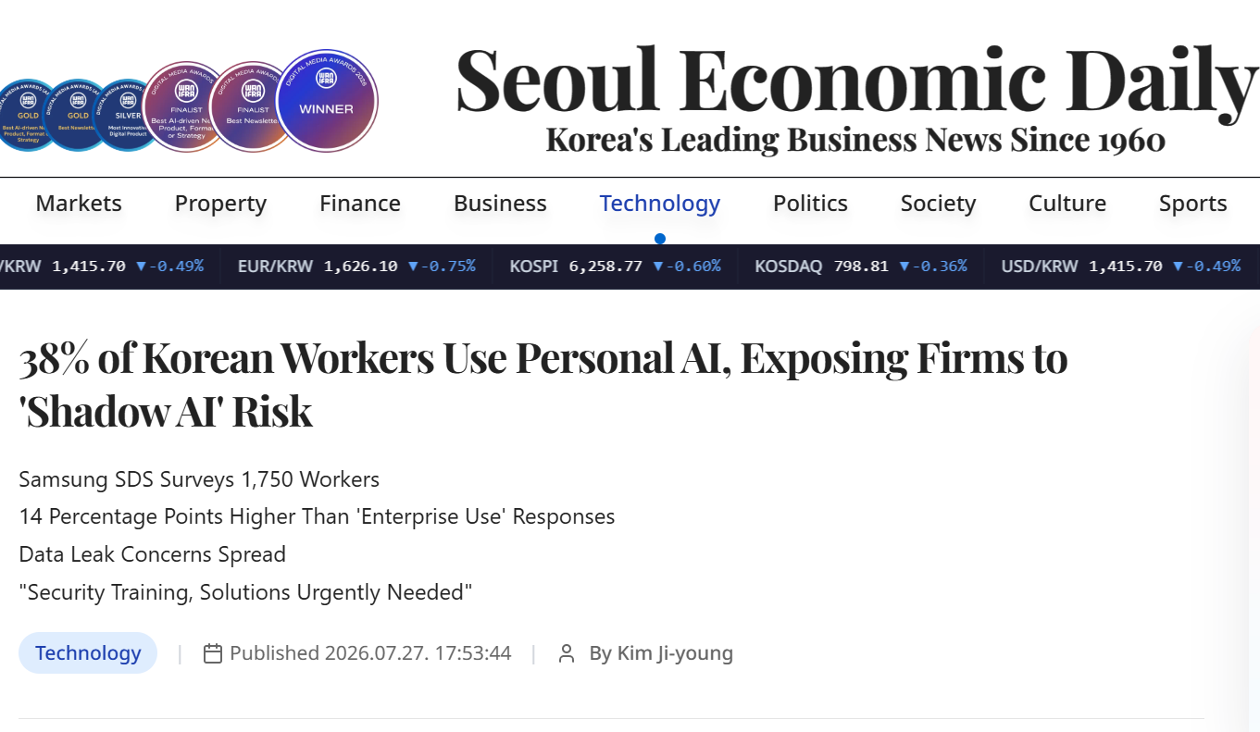

Headline
38% of Korean Workers Use Personal AI, Exposing Firms to Shadow AI Risk
Source
SEOUL ECONOMIC DAILY
Date
27 July 2026
Risk Tag
SHADOW AI
Description
A Samsung SDS survey found that 38% of employees were using personally subscribed AI services for work instead of enterprise-approved platforms. The findings highlighted growing concerns around unsanctioned AI use and potential data leakage.

TOKENMAXXING
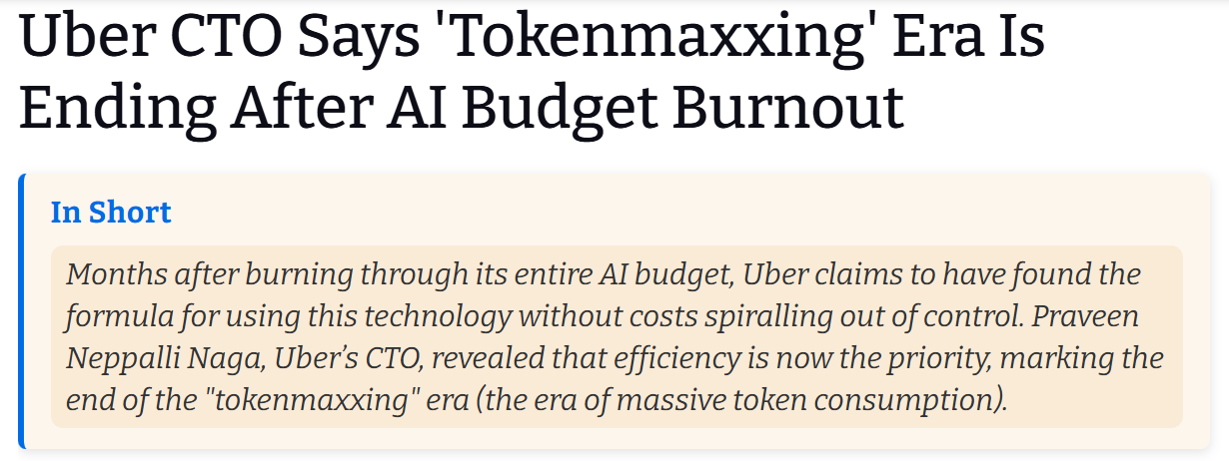

Headline
Uber CTO Says Tokenmaxxing Era Is Ending After AI Budget Burnout
Source
THE HANS INDIA
Date
2026
Risk Tag
TOKENMAXXING
Description
Uber's CTO warned against the trend of indiscriminately consuming AI tokens and model capacity without considering cost, efficiency, or business value. The article highlights the growing need for governance, optimization, and responsible AI consumption as organizations scale AI adoption.

VALUE LEAKAGE

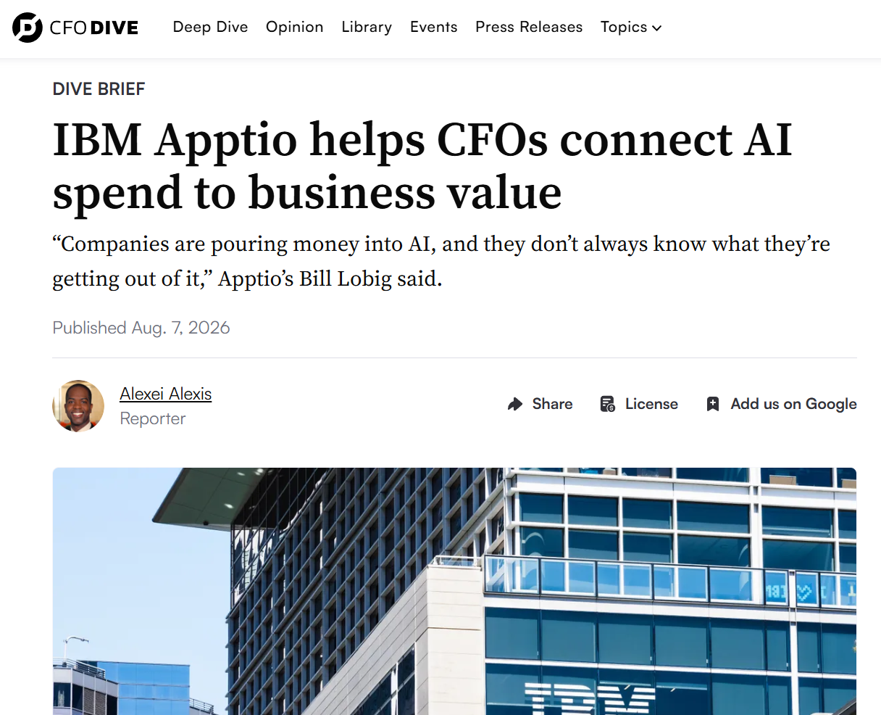

Headline
IBM Apptio Helps CFOs Connect AI Spend to Business Value
Source
CFO Dive
Date
2026
Risk Tag
AI VALUE REALIZATION
Description
As AI budgets grow, many leadership teams struggle to distinguish genuine business impact from AI experimentation and usage statistics.
Many organizations are accelerating AI adoption, yet executives often lack visibility into governance mechanisms that connect AI investment decisions with business outcomes.

